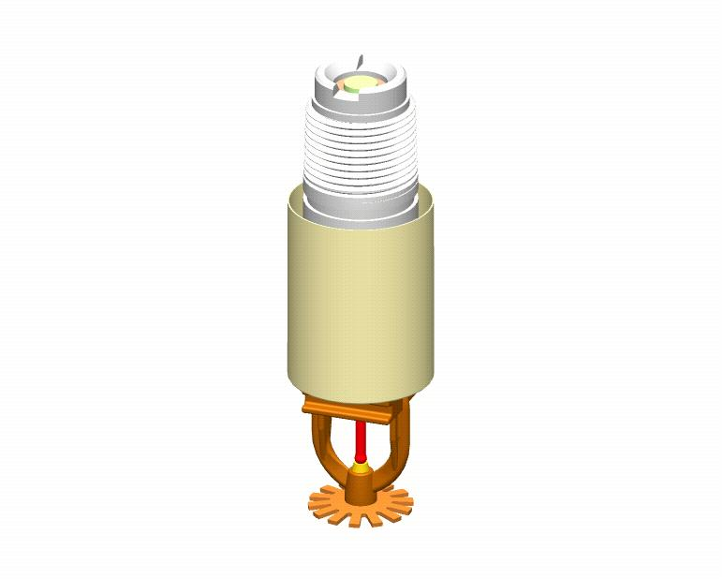

Engineering Specification
Model F3QR
Quick Response Dry Sprinklers

Quick Response Dry Pendent Sprinklers

Sprinklers shall be control mode, quick response [cULus Listed] [NYC MEA Approved, 259-93-E] [FM Approved] dry pendent style sprinklers. Sprinkler and deflector shall be of all brass frame construction attached to a 1” diameter galvanized extension nipple of specified length, (“A” dimension - 2” (51 mm) to 48” (1219 mm), measured from face of fitting to ceiling/wall surface) having a machined 1” NPT thread. Extension nipple shall have an extended inlet above the thread, having a minimum dimension of X” (mm). Internal construction shall consist of an inner tube/yoke assembly with orifice adapter consisting of all brass parts. Inlet seal assembly shall consist of a Teflon-coated Belleville spring washer with brass cap. Sprinklers shall have a 5 mm frangible glass bulb thermal operating element with sealed adjustable seat adapter in conformance with UL requirements. Nominal K-factor of dry sprinklers shall be 5.6 (81.0) and the sprinkler temperature rating shall be [135 °F (57 °C)] [155 °F (68 °C)] [200 °F (93 °C)] [286 °F (141 °C)]. Rated working pressure shall be 175 psi (12.1 bar). Dry pendent sprinklers shall be capable of providing 1-1/2” (38 mm) of escutcheon adjustment. Standard finishes: [Bronze] [Chrome-plated] [White Painted] [Special finish– specify]. [Optional - Exposed dry pendent sprinklers subject to corrosive atmospheres shall have a factory applied corrosion resistant coating] [Dry sprinklers subject to damage shall have a listed/approved sprinkler guard for impact protection]. Quick response dry pendent sprinklers shall be Reliable Model F3QR, SIN R5714 (Bulletin 157).

Quick Response Dry Recessed Pendent Sprinklers

Replace “pendent” with “recessed pendent” and ““A” dimension - 2” (51 mm) to 48” (1219 mm)” with ““A” dimension - 3-1/2” (89 mm) to 48” (1219 mm). Add: Recessed escutcheon assembly shall be a factory assembled, two-piece steel escutcheon of push-on and thread-off design capable of providing ½” of escutcheon adjustment. Standard finish shall be [Bronze] [Chrome-plated] [White Painted] [Specialty – specify]. Quick response dry recessed pendent sprinklers shall be Reliable Model F3QR, SIN R5714 (Bulletin 157).

Dry Concealed Pendent Sprinklers

Replace “pendent” with “concealed pendent” and “A” dimension - 2” (51 mm) to 48” (1219 mm) with “A” dimension - 3-1/2” (89 mm) to 48” (1219 mm). Add: Cover plate assembly shall consist of a brass cover plate and copper alloy retainer flange. Method of attaching the cover plate to the sprinkler cup shall be a push-on and thread-off design capable of providing 3/8” (9.5 mm) of cover plate adjustment. Cover plate temperature rating shall be [135 °F (57 °C)] [165 °F (74 °C)]. A factory-applied protective cap shall be provided to protect against installation damage. Standard cover plate finish to be: [Chrome Plated] [White] [Specialty – specify]. Quick response dry recessed pendent quick response sprinklers shall be Reliable Model F3QR, SIN R5714 (Bulletin 157).

Quick Response Dry Horizontal Sidewall Sprinklers

Replace “pendent” with “horizontal sidewall.” Add: Quick response dry horizontal sidewall sprinklers shall be capable of providing 1-1/2” (38 mm) of escutcheon adjustment. Quick response dry horizontal sidewall sprinklers shall be Reliable Model F3QR, SIN R5734 (Bulletin 157).

Quick Response Dry Recessed Horizontal Sidewall Sprinklers

Replace “pendent” with “ recessed horizontal sidewall” and ““A” dimension - 2” (51 mm) to 48” (1219 mm)” with ““A” dimension - 3-1/2” (89 mm) to 48” (1219 mm).” Add: Recessed escutcheon assembly shall be a factory assembled, two-piece steel escutcheon of push-on and thread-off design capable of providing ½” (13 mm) of escutcheon adjustment. Quick response dry recessed horizontal sidewall sprinklers shall be Reliable Model F3QR, SIN R5734 (Bulletin 157).

